# Hosting my Static Website in an AWS S3 Bucket

## And you can do the same too!

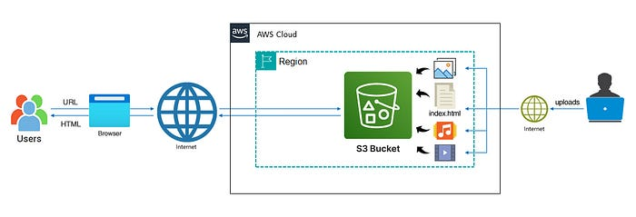

— Architecture Diagram of Hosting my Professional Resume Website in an AWS S3 Bucket

After spending a very long time designing and creating my [professional resume website](https://www.rogernem.com) I wanted to show it to the world, but how?! 😱

In this guide, you will embark in a journey to understand the different terminologies, discover the different types of hosting and how to choose a solution that fits your needs.

* This is the [first part](https://medium.com/@rogernem/hosting-my-static-website-in-an-aws-s3-bucket-d5e1d94417f4) of the series of 4 parts, where I start with the simplest solution.
* Part 2 covers some improvements that can be achieved with **Amazon CloudFront.**
* Part 3 shows the final enhancements using **Amazon Route 53.**
* The last part shows how to build the infrastructure used here with the **Terraform — IaC.**

And if this is the first time you are hearing about “static”, “hosting”, “AWS”, and “S3 Bucket”, don’t worry. I have written some articles (links below) you can refer to for clarifications.

# Table of Contents

1. [Prerequisites](https://medium.com/@rogernem/hosting-my-static-website-in-an-aws-s3-bucket-d5e1d94417f4#d683)
2. [Static vs Dynamic Websites](https://medium.com/@rogernem/hosting-my-static-website-in-an-aws-s3-bucket-d5e1d94417f4#7401)
3. [Types of Web Hosting](https://medium.com/@rogernem/hosting-my-static-website-in-an-aws-s3-bucket-d5e1d94417f4#bfad)
4. [Amazon Web Services (AWS)](https://medium.com/@rogernem/hosting-my-static-website-in-an-aws-s3-bucket-d5e1d94417f4#6a2f)
5. [Amazon Simple Storage Service (Amazon S3)](https://medium.com/@rogernem/hosting-my-static-website-in-an-aws-s3-bucket-d5e1d94417f4#49f9)
6. [My Solution using Amazon S3](https://medium.com/@rogernem/hosting-my-static-website-in-an-aws-s3-bucket-d5e1d94417f4#da06)  
   – [Step 1: Creating my S3 bucket](https://medium.com/@rogernem/hosting-my-static-website-in-an-aws-s3-bucket-d5e1d94417f4#360b)  
   – [Step 2: Enabling static website hosting](https://medium.com/@rogernem/hosting-my-static-website-in-an-aws-s3-bucket-d5e1d94417f4#8f60)  
   – [Step 3: Securing my S3 bucket through IAM policies](https://medium.com/@rogernem/hosting-my-static-website-in-an-aws-s3-bucket-d5e1d94417f4#2d4a)  
   – [Step 4: Uploading web files to my S3 bucket](https://medium.com/@rogernem/hosting-my-static-website-in-an-aws-s3-bucket-d5e1d94417f4#3e84)  
   – [Step 5: Testing my website endpoint](https://medium.com/@rogernem/hosting-my-static-website-in-an-aws-s3-bucket-d5e1d94417f4#4a10)

# Prerequisites

To follow along this guide, please make sure the following requirements are met:

* **AWS account:** You can sign up [here](https://aws.amazon.com/) and follow this [tutorial](https://aws.amazon.com/premiumsupport/knowledge-center/create-and-activate-aws-account/) to set it up.
* A static website. — you can refer to my github repository for my website.

## [static-website-on-aws · rnem/aws](https://github.com/rnem/aws/tree/main/projects/static-website-on-aws/www.rogernem.com?source=post_page-----d5e1d94417f4--------------------------------" \t "_blank)

### [My collection of all things Amazon Web Services (AWS)](https://github.com/rnem/aws/tree/main/projects/static-website-on-aws/www.rogernem.com?source=post_page-----d5e1d94417f4--------------------------------" \t "_blank)

[github.com](https://github.com/rnem/aws/tree/main/projects/static-website-on-aws/www.rogernem.com?source=post_page-----d5e1d94417f4--------------------------------" \t "_blank)

# Static vs Dynamic Websites

## [Static vs Dynamic Websites](https://medium.com/@rogernem/static-vs-dynamic-websites-4cc7dff82b7e?source=post_page-----d5e1d94417f4--------------------------------" \t "_blank)

### [Navigating the Distinctions Between Static and Dynamic Websites](https://medium.com/@rogernem/static-vs-dynamic-websites-4cc7dff82b7e?source=post_page-----d5e1d94417f4--------------------------------" \t "_blank)

In my case, based on the article I wrote above and because my resume doesn’t need to be updated frequently, the best option is to create it as a static website.

# Types of Web Hosting

In the digital age, where online presence is the linchpin of success, the importance of a robust website cannot be overstated. Yet, amidst the meticulous design, compelling content, and strategic SEO efforts, one often overlooked aspect that can significantly impact a website’s performance is the choice of web hosting.

Check out the article below for more details on the different types of web hosting services.

## [Types of Web Hosting](https://medium.com/@rogernem/types-of-web-hosting-bb6d1162fc76?source=post_page-----d5e1d94417f4--------------------------------" \t "_blank)

### [Most Common Categories of Web Hosting Services](https://medium.com/@rogernem/types-of-web-hosting-bb6d1162fc76?source=post_page-----d5e1d94417f4--------------------------------" \t "_blank)

[www.rogernem.com](https://medium.com/@rogernem/types-of-web-hosting-bb6d1162fc76?source=post_page-----d5e1d94417f4--------------------------------" \t "_blank)

# Amazon Web Services (AWS)



**Amazon Web Services (AWS)** is the world’s most comprehensive, evolving cloud computing platform provided by Amazon that includes a mixture of infrastructure-as-a-service (IaaS), platform-as-a-service (PaaS) and packaged-software-as-a-service (SaaS) offerings. AWS services offers over 200 fully featured services from data centers globally.

Amazon.com Web Services launched its first web services in 2002 from the internal infrastructure that Amazon.com built to handle its online retail operations. In 2006, it began offering its defining IaaS services. AWS was one of the first companies to introduce a pay-as-you-go cloud computing model that scales to provide users with compute, storage or throughput as needed.

You can learn more at <https://aws.amazon.com/what-is-aws/>.

# Amazon Simple Storage Service (Amazon S3)

Check out the article below for more details on Amazon S3.

## [Amazon Simple Storage Service (Amazon S3)](http://Amazon Simple Storage Service (Amazon S3)AWS Object Storage Servicewww.rogernem.com)

### [AWS Object Storage Service](http://Amazon Simple Storage Service (Amazon S3)AWS Object Storage Servicewww.rogernem.com)

[www.rogernem.com](http://Amazon Simple Storage Service (Amazon S3)AWS Object Storage Servicewww.rogernem.com)

# My Solution using Amazon S3

Due to all of the [benefits of Amazon S3](https://medium.com/@rogernem/amazon-simple-storage-service-eb0808cf30d5), I have chosen to host my [professional resume website](https://www.rogernem.com) in an AWS S3 Bucket.

## Step 1: Creating my S3 bucket

The first step you need to take is to create an S3 bucket to put your website’s files and folders.

1. Sign in to the AWS Management Console
2. Open the Amazon S3 console at <https://console.aws.amazon.com/s3/>.

This should display the S3 dashboard.

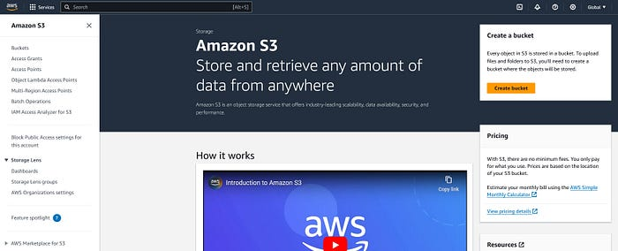

3. Click on **Create bucket**

4. **Choose a Region** that is geographically close to you to minimize latency and costs, or to address regulatory requirements. The Region that you choose determines your Amazon S3 website endpoint.

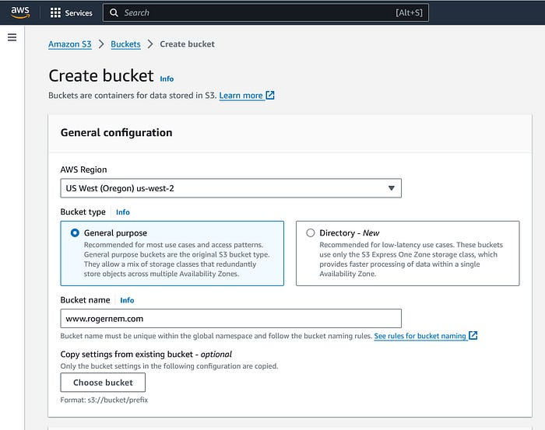

**NOTE**: The **name** of an S3 bucket is **unique GLOBALLY** but a **bucket** is always **created in the region you specify** and never leaves that region until you transfer its objects to another one.

5. Under “**Block Public Access settings for this bucket”** section, uncheck the “**Block all public access”** checkbox and accept the acknowledgement.

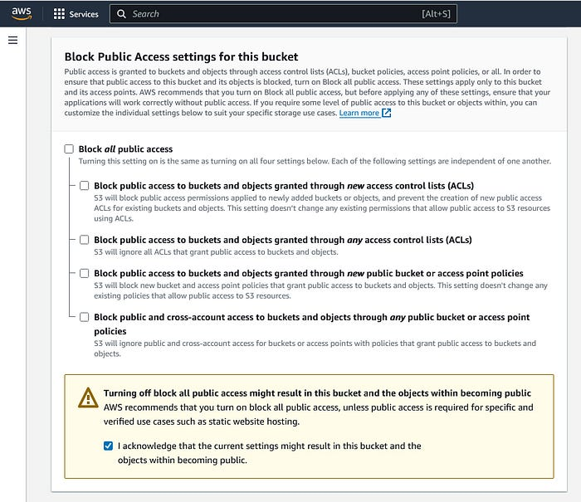

**NOTE**: Since you are going to host a website in this S3 Bucket, this needs to be done to make the S3 bucket accessible to the public.

6. Select “**Disable”** for Bucket Versioning.

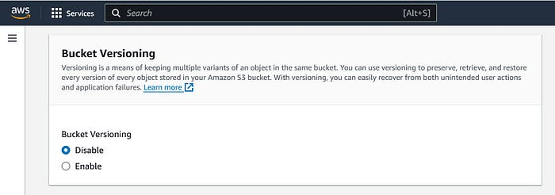

7. Optional: You can “**Add tag”** to your bucket for easy identification.

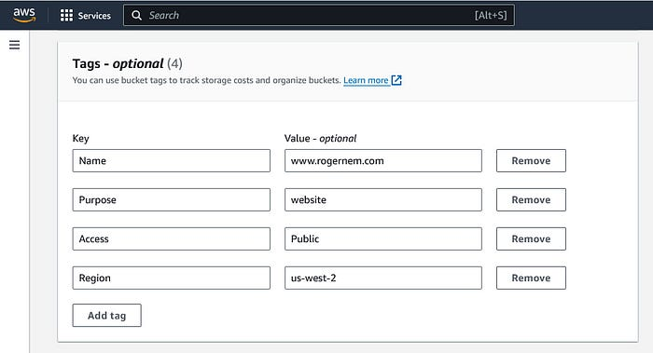

8. Under “**Default encryption”** section, click on **disable** for Server-side encryption.

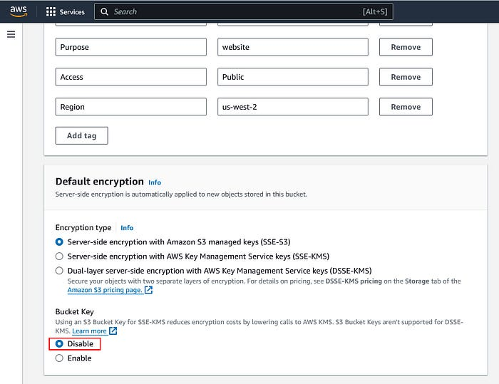

9. Click on “**Create bucket”**.

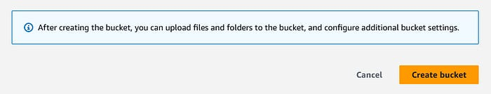

You should see the following message and screen.

Successfully created bucket “**www.rogernem.com**"  
To upload files and folders, or to configure additional bucket settings, choose **View details**.

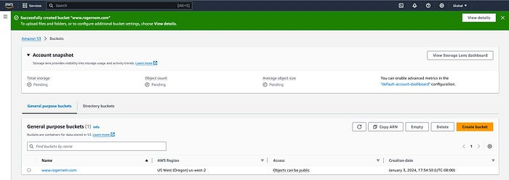

## Step 2: Enabling static website hosting

1. In the **Buckets** list, choose the name of the bucket that you want to enable static website hosting for (www.rogernem.com).

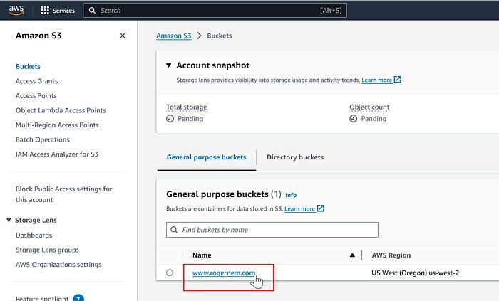

2. Click on the “**Properties”** tab**.**

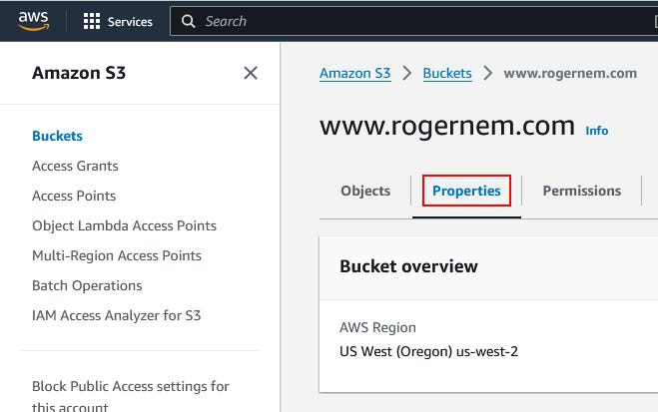

3. Scroll down to the “**Static website hosting”** section and click on its **Edit** button.

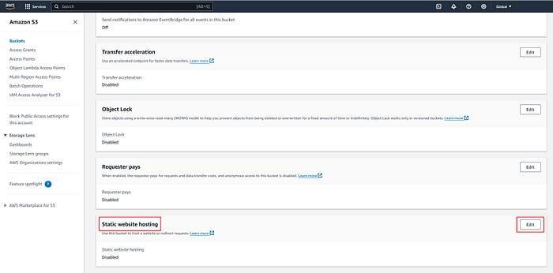

4. Under **Static website hosting**, choose **Enable** (1). Also, select **Host a static website** (2) for the Hosting type. In **Index document**, enter the file name of the index document, typically index.html(3).

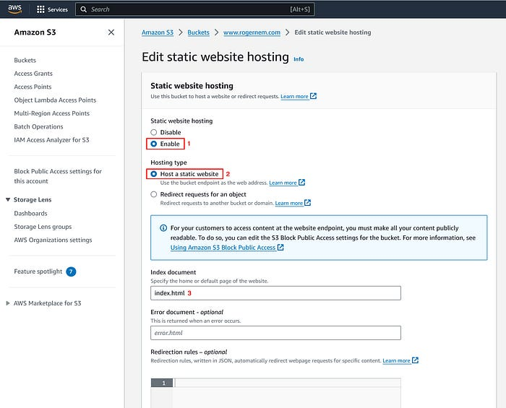

5. Click on “**Save Changes**”. You should see the following next.

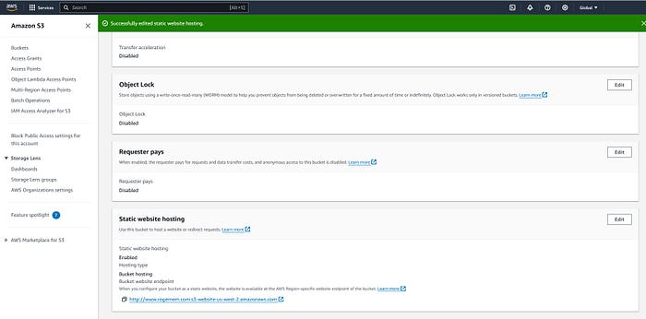

Under **Static website hosting**, note the **Endpoint** which is the Amazon S3 website endpoint for your bucket.

NOTE: After finishing configuring your bucket as a static website, you can use this endpoint to test your website.

## Step 3: Securing my S3 bucket through IAM policies

To allow users to access your website and to secure your S3 bucket and block uploads and/or deletions, you will need to add a bucket policy.

1. Under **Buckets**, click on the name of your website bucket.



2. Click on the “**Permissions”** tab**.**

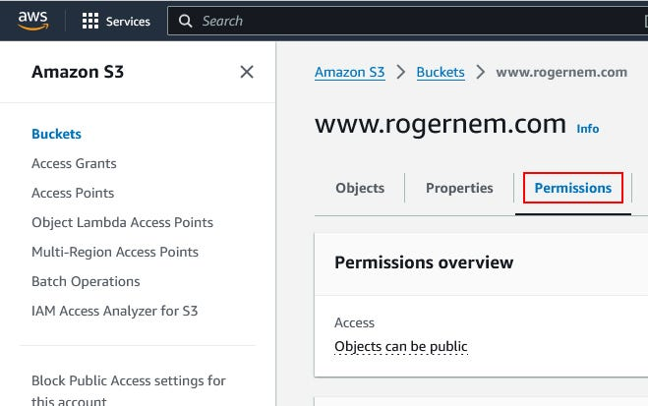

3. Under **Bucket Policy**, choose **Edit**.

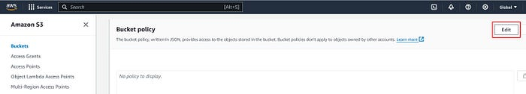

4. To grant public read access for your website, copy the following bucket policy, and paste it in the **Bucket policy editor**. Make sure to replace bucket-name with the name of your bucket.

{  
 "Version": "2012-10-17",  
 "Statement": [  
 {  
 "Sid": "PublicReadGetObject",  
 "Effect": "Allow",  
 "Principal": "\*",  
 "Action": [  
 "s3:GetObject"  
 ],  
 "Resource": [  
 "arn:aws:s3:::Bucket-Name/\*"  
 ]  
 }  
 ]  
}

NOTE: The Action “s3:GetObject” with Effect “Allow” let users browse your website.

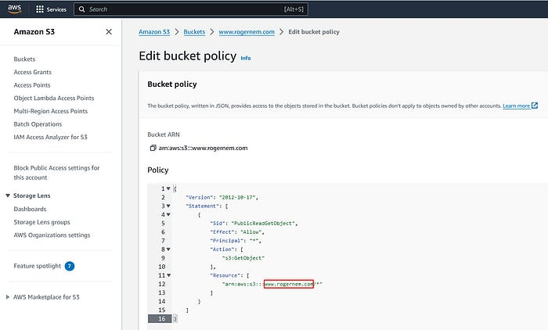

5. Scroll down and click on “**Save changes”**. You should see the following next.

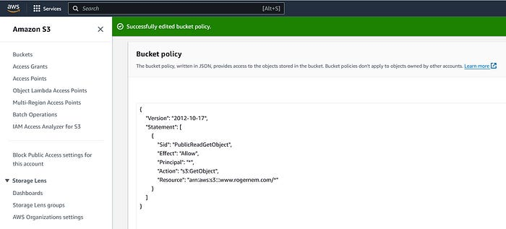

## Step 4: Uploading web files to my S3 bucket

After completing all the previous steps, you need to upload your website’s files and folders to your website S3 bucket.

1. Under **Buckets**, click on the name of your website bucket.



2. On the **Objects** tab, you can see that the bucket is currently empty, click on the **Upload** button.

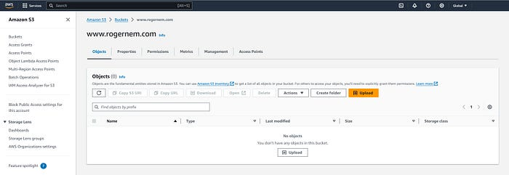

3. This should take you to the **Upload** page. Click **Add files** to add the website files and use **Add folder** to add the website folders.

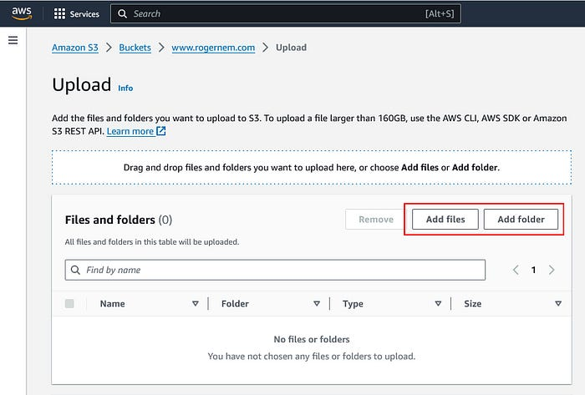

**Note**: The whole website folder shouldn’t be added all at once. Instead, add its content one after the other.

After the necessary files and folders have been added, scroll down and click on **Upload**. The upload should be done in a few minutes depending on your network and website content size.

NOTE: Do not close the tab while the upload process is happening.

## Step 5: Testing my website endpoint

1. Under **Buckets**, click on the name of your website bucket.



2. Click on the “**Properties”** tab**.**



3. Scroll down to the “Static website hosting” section and click on your endpoint URL.

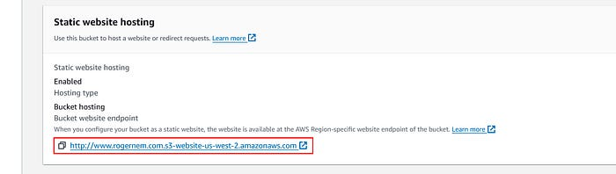

You should be able to see your website now.   
Yay!🎉 Congratulations. That’s it!



My Professional Resume Website — www.rogernem.com

**. . .**

**If you enjoyed this article and found it helpful, please don’t forget to leave a heart** ❤**, comment** 💬**, clap** 👏🏻**, and share** ➦ **it to show your support.**

**Also, don’t forget to** [**follow me**](https://medium.com/@rogernem) **for more articles. Thank you!**

**. . .**

References:  
- <https://aws.amazon.com/what-is-aws/>  
- <https://en.wikipedia.org/wiki/Amazon_Web_Services>  
- <https://docs.aws.amazon.com/AmazonS3/latest/userguide/Welcome.html>  
- <https://docs.aws.amazon.com/AmazonS3/latest/userguide/getting-started-next-steps.html>  
- <https://docs.aws.amazon.com/AmazonS3/latest/userguide/HostingWebsiteOnS3Setup.html>